Project:- Terraform IaC for VM

Description

Use Terraform to provision infrastructure

**Description:**

Nowadays, infrastructure automation is critical. We tend to put the most emphasis on software development processes, but infrastructure deployment strategy is just as important. Infrastructure automation not only aids disaster recovery, but it also facilitates testing and development.

Your organization is adopting the DevOps methodology and in order to automate provisioning of infrastructure there's a need to set up a centralized server for Jenkins.

Terraform is a tool that allows you to provision various infrastructure components. Ansible is a platform for managing configurations and deploying applications. It means you'll use Terraform to build a virtual machine, for example, and then use Ansible to install the necessary applications on that machine.

Considering the Organizational requirement you are asked to automate the infrastructure using Terraform first and install other required automation tools in it.

**Tools required:** Terraform, AWS account with security credentials, Keypair

**Expected Deliverables:**

* Launch an EC2 instance using Terraform
* Connect to the instance
* Install Git, Ansible, Jenkins, Java and Python in the instance

SOLUTION:

* + 1. Create a key pair in AWS which will be used later. Download them and save it in your system.
    2. Create an IAM User and generate public access and secret access key and save in your machine in notepad.
    3. Create a directory for the terraform project. Create a terraform file for saving AWS credentials with extension .tf. Save AWS region, secret access key and public access key in this file.
    4. Install AWS CLI in your machine. After that, With the AWS Configure command, Add the public and private access key, with the region and other details, as per need. These details will be considered as default details which terraform will use if some detail is not mentioned in the .tf file. These details will be saved in the AWS home directory in the AWS credentials.
    5. After adding the details in the AWS configure file, you can remove key detail from the .tf file in the terraform directory, and give the AWS home root path instead, where your default keys and other credentials are saved. Generally the root path is —> [“~/.aws/credentials”] —> here you can find the AWS Credentials you have given.  
       Please note-: Details provided in the .tf files will be considered first by the terraform. If some detail is not present there, then terraform will pick detail from AWS home directory .
    6. Write the terraform file specifying the, AWS resource block in the terraform file, giving the instance type, name and other details.
    7. Write the Security Group block in the terraform file, containing the port number, CIDR IP address details, ingress egress network, and other network security details, which needs to be specified.
    8. Write the data you want to call within the instance. Here, we are installing git, ansible in our created instance. But prior to that, we will need to connect to our instance, via EDI key pair which was generated in the first step, so that we can access our instance and make changes on it. Mention the key name in the AWS resource block in the last tag.
    9. Connect the security group with the AWS resource block.
    10. Plan and apply the terraform. The instance will be successfully generated with the git and ansible installed on it.  
          
          
        ============PART 1 OF PROJECT COMPLETED! ====================  
        PART 2: Not added in this project. But you can find the reference in the Ansible module Number 1 , 2 and 3, attached in the Ansible repository.  
        ===========================================================
    11. After the instance has been generated, add the ansible in the controller machine. Create a user In the worker node (instance) and give relevant permissions. Perform the same steps in the worker nodes. After that, on the controller machine  
        Generate the ssh key and copy the key on the worker node (instance) to connect with them via ssh.
    12. Add the worker node IP address in the host file of ansible and Ping the worker node to check if connection is successful or not. After successful connection, we will write ansible playbook to install java, python and Jenkins on our worker node.
    13. Execute the playbook and check if the java, python and Jenkins were successfully installed or not on the worker node by checking their version, You can di it via ansible module or manually via worker node console.
    14. LINKS:-  
        <https://registry.terraform.io/providers/hashicorp/aws/latest/docs>

EXECUTION :-

1. Create the key pair  
   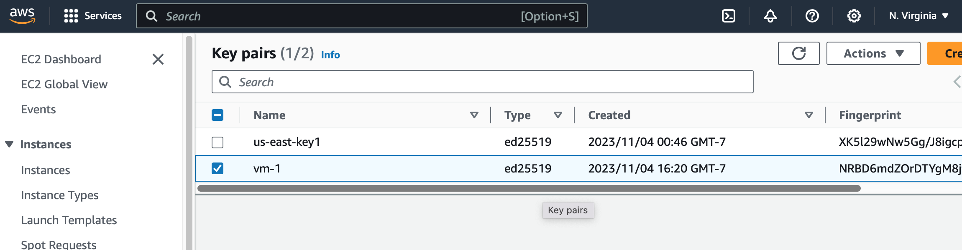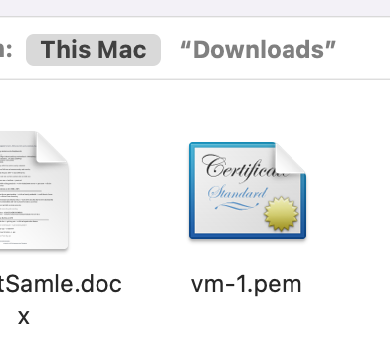
2. Generate security key from IAM user  
   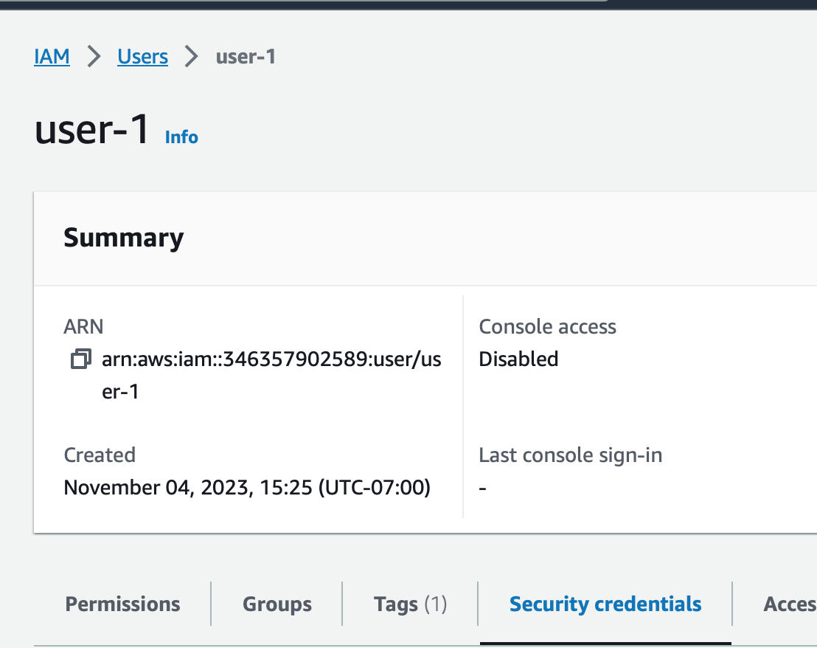  
   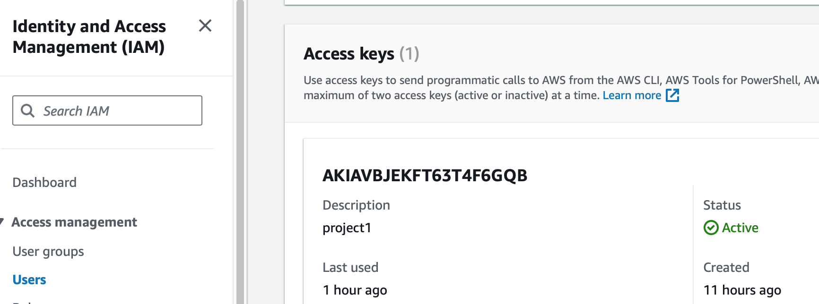
3. Add the keys credentials  
     
     
     
   —> vim aws_config.tf  
   In this file add the keys in this format  
   <https://registry.terraform.io/providers/hashicorp/aws/latest/docs>  
   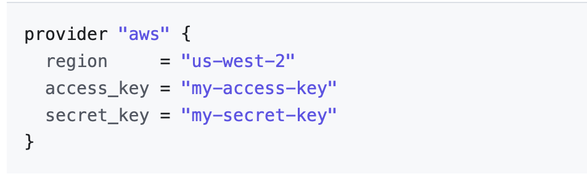
4. You can save credentials in AWS configure as well  
   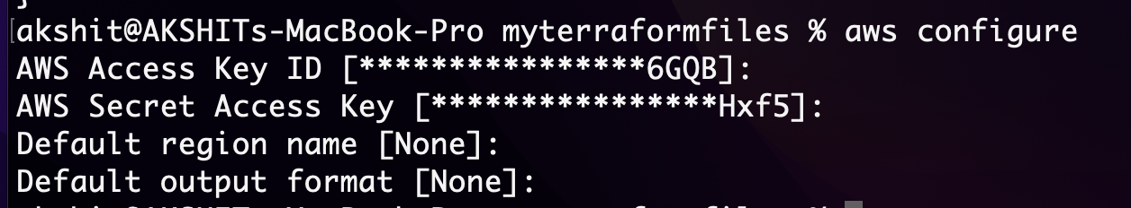
5. Here in shared_credentials_files we have not provided the secret access key directly but reference to the path of AWS home directory credentials file.  
   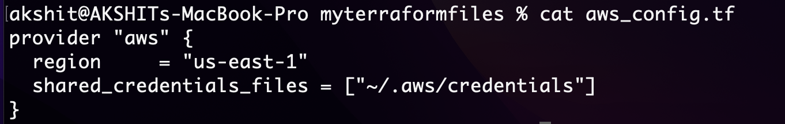
6. Make a file with .tf extension with all the instance details  
   
7. Security Block  
     
   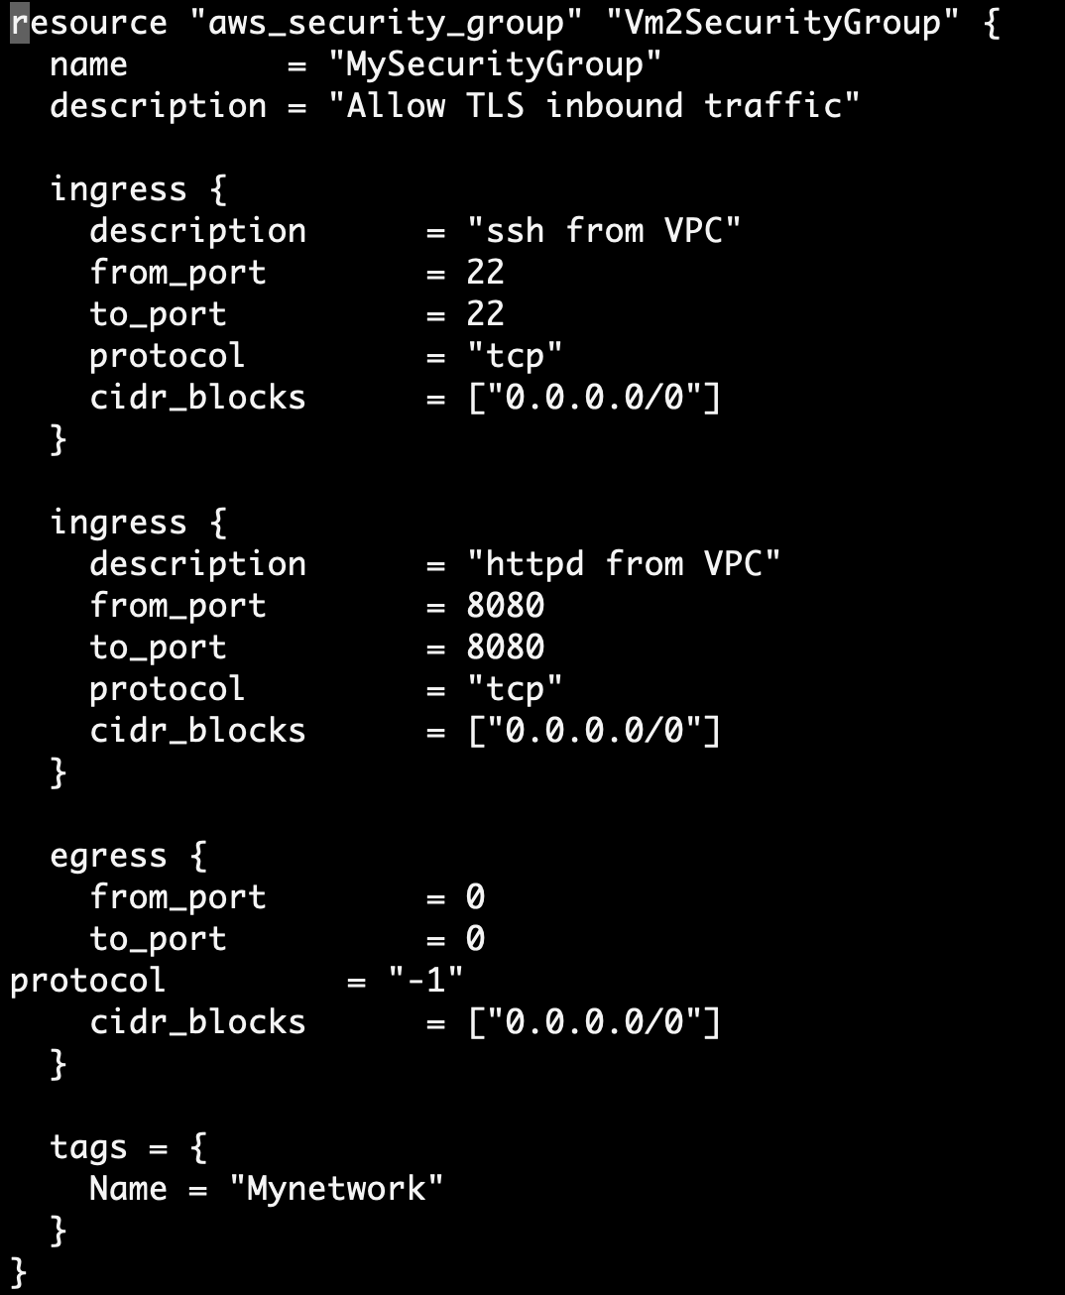
8. Add key and the script for installation. The AWS resource block will now looks like this  
     
   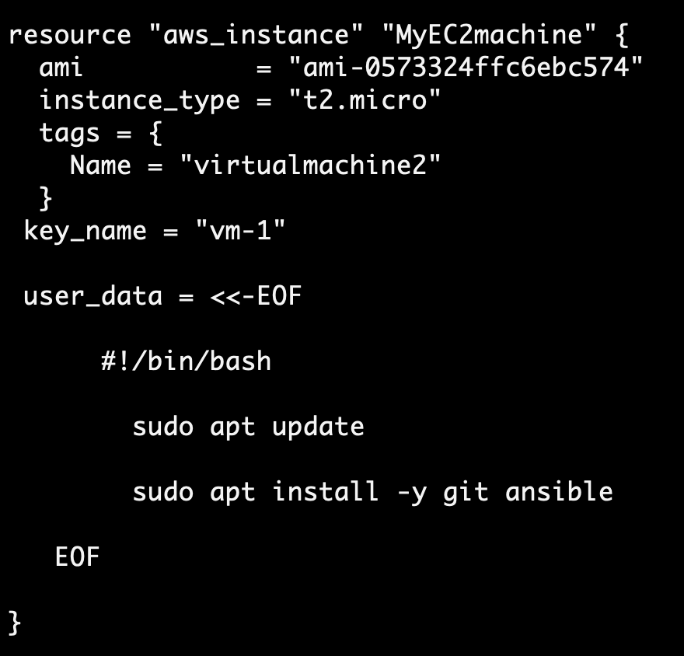
9. Connect resource block with network block.  
   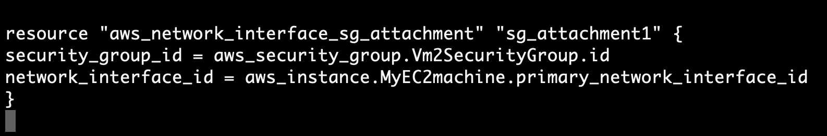
10. Apply terraform  
      
      
      
      
      
      
    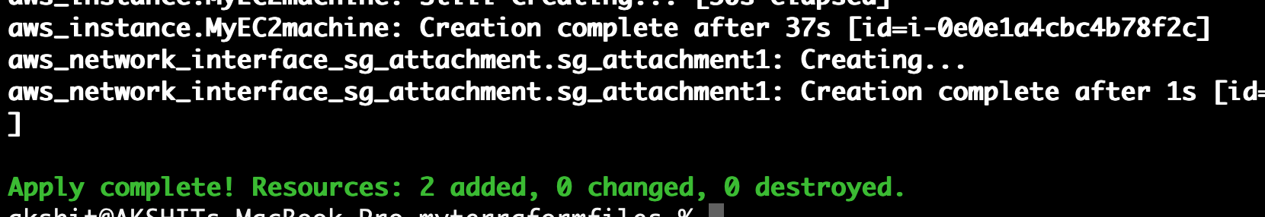  
      
      
      
    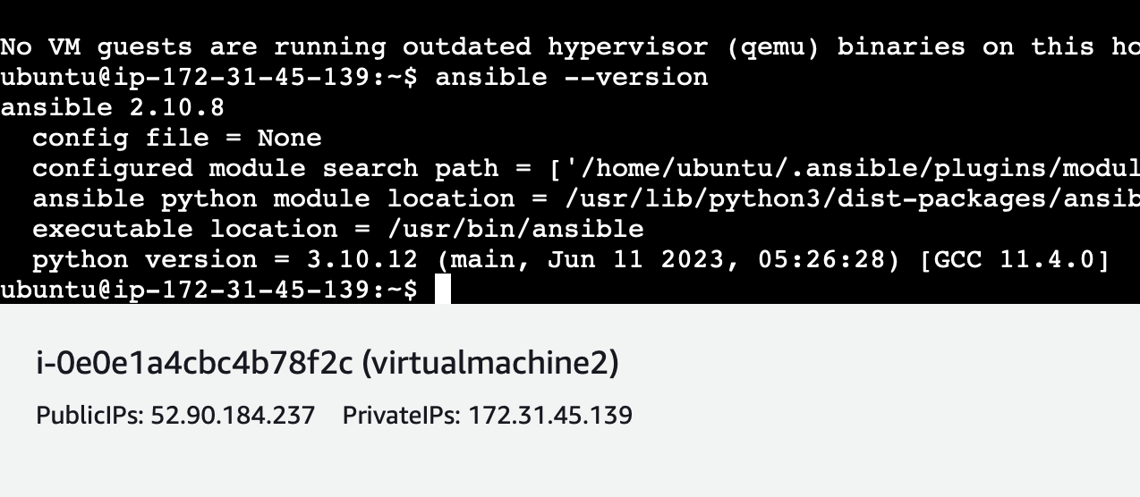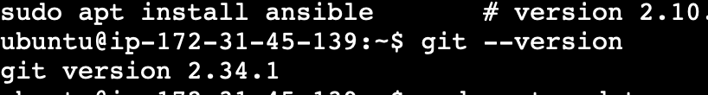  
      
    Git and Ansible are successfully installed and instance has been successfully created.  
      
      
      
      
      
      
      
      
      
      
      
      
      
      
      
      
    